10. ReactJS-HOL.docx:
Create a react app with name “officespacerentalapp”
& open it in the vs code.
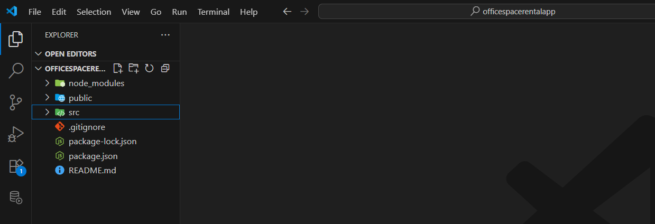
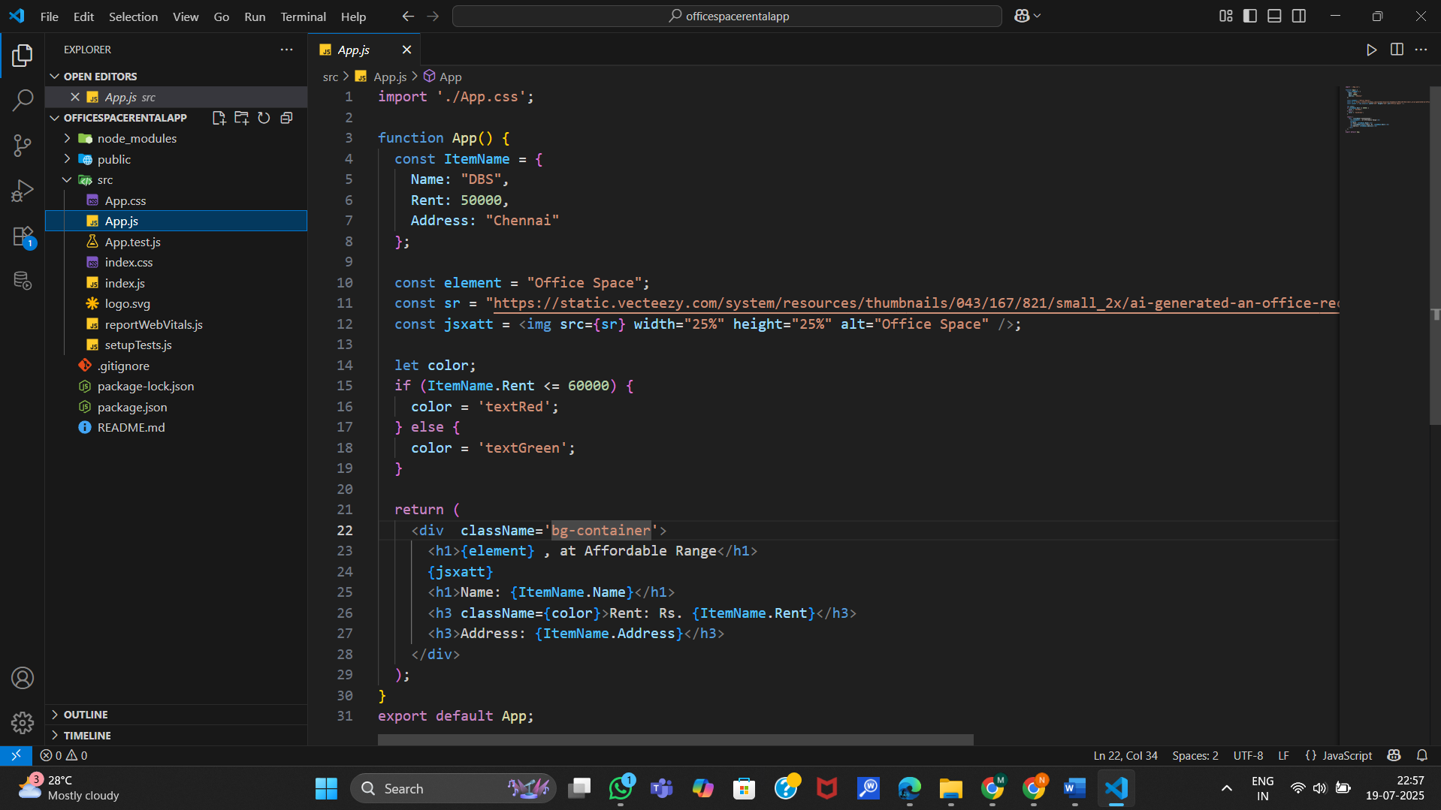
Output:
